**PRACTICAL-7**

**Aim: Develop applications using PHP and MYSQL**

**Practical-7.1: Make an application using PHP that collects student information like name, PEN, Gender (use Radio Button), Branch (use Drop Down Box), Semester, Contact number (Text Box should masked with numbers only) and address. Create buttons for Insert, Delete, Update and Retrieve the details in/from the database. Alter the table to add a column and add data in that new column**

**Program:**

<html>

<title>Practical-7_1</title>

<style>

body{

background-image:url('homepage.jpg');

background-size: 100% 100%;

}

h1{

color:white;

}

h2{

color:white;

}

a{

color:yellow;

}

</style>

<body >

<center>

<h1>Student Information</h1>

<h2>Insert data:-<a href="insert.php">Insert</a><br><br></h2>

<h2>Delete data:-<a href="delete.php">Delete</a><br><br></h2>

<h2>Update data:-<a href="update.php">Update</a><br><br></h2>

<h2>Retrive data:-<a href="retrieve.php">Retrive</a><br><br></h2>

</body>

</html>

**OUTPUT:**

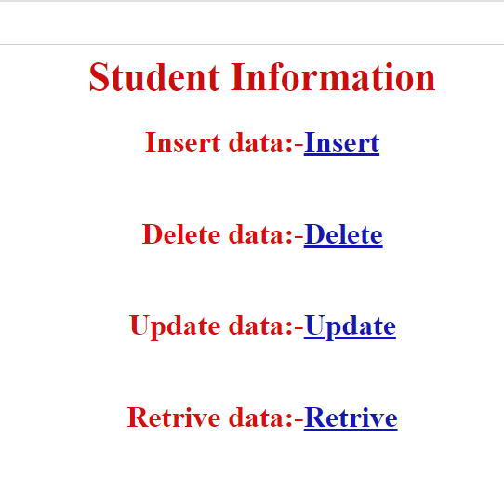

**insert.php**

<html>

<head>

</head>

<body>

<div>

<center>

<h1>Enter data for Student</h1>

<form method="post">

Name:<input type="text" name="name"/><br><br>

Pen No:<input type="text" name="rno"/><br><br>

Gender:

<input type="radio" name="gender" value="MALE"/>Male

<input type="radio" name="gender" value="FEMALE"/>Female

<br><br>

Branch:

<select name="branch">

<option value="Computer">Computer</option>

<option value="Civil">Civil</option>

<option value="Electrical">Electrical</option>

<option value="Mechanical">Mechanical</option>

<option value="Mechanical">Chemical</option>

</select>

<br><br>

Semester:<input type="number" name="sem"/><br><br>

Contact number:<input type="number" name="cno"/><br><br>

<input type="submit" name="OK" /> <a href="pr_7-1_home_page.php">Home</a>

</form>

</center>

<?php

$con=mysqli_connect("localhost","root","","student");

if(isset($_POST['OK']))

{

$name =$_POST['name'];

$rno =$_POST['rno'];

$gender=$_POST['gender'];

$branch=$_POST['branch'];

$sem=$_POST['sem'];

$cno=$_POST['cno'];

$sql="INSERT INTO pr7student (name,rno,gender,branch,sem,cno) VALUES

('$name','$rno','$gender','$branch','$sem','$cno')";

if ($con->query($sql) === TRUE)

{

echo "<br>New record created successfully";

}

else

{

echo "Error: " . $sql . "<br>" . $con->error;

}

}

?>

</div>

</body>

</html>

**OUTPUT:**

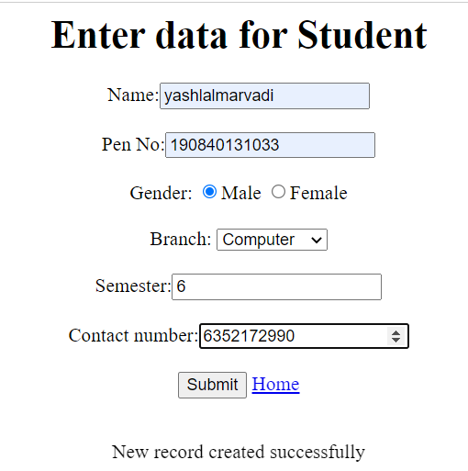

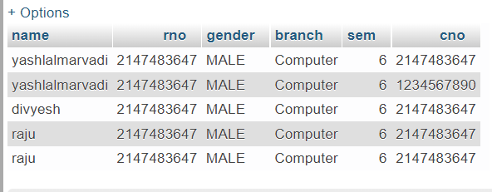

**delete.php**

<form method="post">

roll no:<input type="text" name="rno"/><br><br>

</from>

<input type="submit" name="OK" /> <a href="pr_7-1_home_page.php">Home</a>

<?php

$servername = "localhost";

$username = "root";

$password = "";

$dbname = "studentpr7";

$conn = new mysqli($servername, $username, $password, $dbname);

if ($conn->connect_error) {

die("Connection failed: " . $conn->connect_error);

}

if(isset($_POST['OK']))

{

$rno =$_POST['rno'];

$sql = "DELETE FROM pr7student WHERE rno=$rno";

if ($conn->query($sql) === TRUE)

{

echo "<br>Record deleted successfully";

}

else

{

echo "<br>Error deleting record: " . $conn->error;

}

}

$conn->close();

?>

**OUTPUT:**



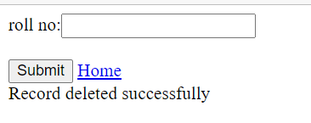

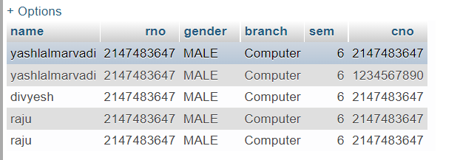

**update.php**

<form method="post">

<h1>Enter the values to update:</h1>

Name:<input type="text" name="name"/><br><br>

Roll no:<input type="text" name="rno"/><br><br>

</from>

<input type="submit" name="OK" /> <a href="pr_7-1_home_page.php">Home</a>

<?php

$servername = "localhost";

$username = "root";

$password = "";

$dbname = "studentpr7";

$conn = new mysqli($servername, $username, $password, $dbname);

if ($conn->connect_error)

{

die("Connection failed: " . $conn->connect_error);

}

if(isset($_POST['OK']))

{

$name =$_POST['name'];

$rno =$_POST['rno'];

$sql = "UPDATE pr7student SET name='$name' WHERE rno=$rno";

if ($conn->query($sql) === TRUE)

{

echo "Record updated successfully";

}

else

{

echo "<br>Error update record: " . $conn->error;

}

}

$conn->close();

?>

**OUTPUT:**



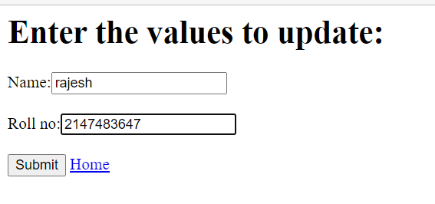

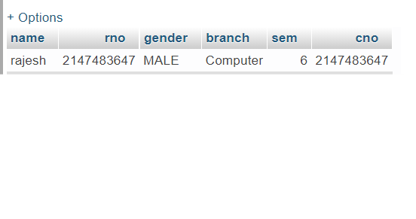

**retrieve.php**

<?php

$servername = "localhost";

$username = "root";

$password = "";

$dbname = "studentpr7";

$conn = new mysqli($servername, $username, $password, $dbname);

if ($conn->connect_error)

{

die("Connection failed: " . $conn->connect_error);

}

$result = mysqli_query($conn,"SELECT * FROM pr7student");

?>

<html>

<head>

<title>Retrive data</title>

</head>

<body>

<?php

if (mysqli_num_rows($result) > 0) {

?>

<table>

<tr>

<td>Name</td>

<td>Roll number</td>

<td>Gender</td>

<td>Branch</td>

<td>Semester</td>

<td>Contact Number</td>

</tr>

<?php

$i=0;

while($row = mysqli_fetch_array($result)) {

?>

<tr>

<td><?php echo $row["name"]; ?></td>

<td><?php echo $row["rno"]; ?></td>

<td><?php echo $row["gender"]; ?></td>

<td><?php echo $row["branch"]; ?></td>

<td><?php echo $row["sem"]; ?></td>

<td><?php echo $row["cno"]; ?></td>

</tr>

<?php

$i++;

}

?>

</table>

<?php

}

Else

{

echo "No result found";

}

?>

<a href="pr_7-1_home_page.php">Home</a>

</body>

</html>

**OUTPUT:**

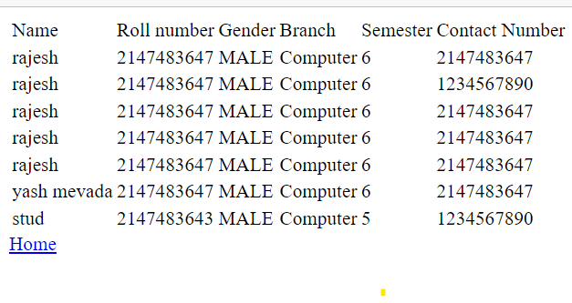

**Practical-7.2: Customize your own WebPages/web application. You may use HTML, Frame Navigation, CSS, JavaScript’s, PHP, Cookies, Session, MYSQL Database Manipulation (Insert, Delete, Update and Retrieve), URL Redirecting, File Uploads, and WEB SERVICES**

**Program:**

**Login page**

<html>

<title>Practical 7_2</title>

<style>

h1{

color:Blue;

}

h3{

color:#6606ad;

}

a{

color:blue;

}

</style>

<body >

<center>

<fieldset>

<h1><u>Welcome</u></h1>

<h2>Login to Continue

</h2>

<form action="home_page.php" method="post" style="padding-top: 50px">

<div class="container">

<label for="uname"><b>Username</b></label>

<input type="text" placeholder="Enter Username" name="uname" required>

<br><br>

<label for="pass"><b>Password</b></label>

<input type="password" placeholder="Enter Password" name="pass" required><br><br>

<button type="submit" name="OK">Login</button><br><br>

<label>

<input type="checkbox" checked="checked" name="remember">

Remember me

</label>

</div>

<div class="container">

<button type="button" class="cancelbtn">Cancel</button><br><br>

</form>

</fieldset>

</div>

</center>

<?php

$con=mysqli_connect("localhost","root","","student");

if(isset($_POST['OK']))

{

$uname =$_POST['usrname'];

$pass =$_POST['pass'];

// $sql=mysqli_query($con,"INSERT INTO login (usern,pass) VALUES ('$uname','$pass')");

$sql=mysqli_query($con,"INSERT INTO login_page (usrname,pass) VALUES ('$uname','$pass')");

}

?>

</body>

</html>

**OUTPUT:**

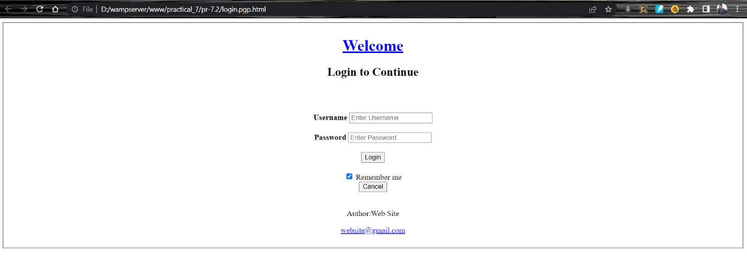

**Home Page**

<html>

<title>Practical-7_1</title>

<style>

body{

background-color: black;

background-size: 100% 100%;

}

h1{

color:white;

}

h2{

color:white;

}

a{

color:yellow;

}

</style>

<body >

<center>

<h1>Student Information</h1>

<h2>Insert data:-<a href="insert.php">Insert</a><br><br></h2>

<h2>Delete data:-<a href="delete.php">Delete</a><br><br></h2>

<h2>Update data:-<a href="update.php">Update</a><br><br></h2>

<h2>Retrive data:-<a href="retrieve.php">Retrive</a><br><br></h2>

</body>

</html>

**OUTPUT:**



**Insert Page:**

<html>

<head>

<title>Insert</title>

</head>

<body>

<div>

<h1>Enter Student data</h1>

<form method="post">

Name:<input type="text" name="name"/><br><br>

Roll number:<input type="text" name="rno"/><br><br>

Gender:

<input type="radio" name="gender" value="MALE"/>Male

<input type="radio" name="gender" value="FEMALE"/>Female

<br><br>

Branch:

<select name="branch">

<option value="Computer">Computer</option>

<option value="Civil">Civil</option>

<option value="Electrical">Electrical</option>

<option value="Mechanical">Mechanical</option>

</select><br><br>

Semester:<input type="number" name="sem"/><br><br>

Contact number:<input type="number" name="cno"/><br><br>

File Upload:<input type="hidden" name="MAX_FILE_SIZE" value="4194304" />

<input type="file" /><br><br>

<input type="submit" name="OK" /> <a href="home_page.php">Home</a>

</form>

<?php

$con=mysqli_connect("localhost","root","","studentpr7");

if(isset($_POST['OK']))

{

$name =$_POST['name'];

$rno =$_POST['rno'];

$gender=$_POST['gender'];

$branch=$_POST['branch'];

$sem=$_POST['sem'];

$cno=$_POST['cno'];

$sql=mysqli_query($con,"INSERT INTO pr7student (name,rno,gender,branch,sem,cno) VALUES ('$name','$rno','$gender','$branch','$sem','$cno')");

}

?>

</div>

</body>

</html>

**OUTPUT:**

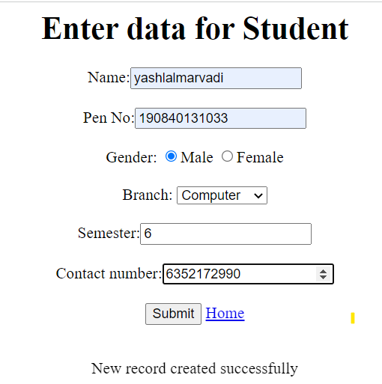

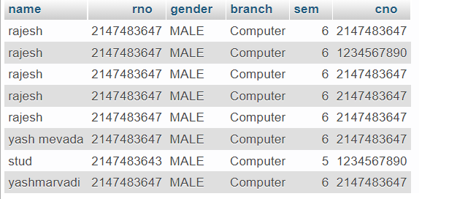

**Delete Page**

<!DOCTYPE html>

<html>

<head>

<title>Delete_Page</title>

</head>

<h1>Enter the Roll number to delete!!!</h1>

<form method="post">

Roll number:<input type="text" name="rno"/><br><br>

</from>

<input type="submit" name="OK" /> <a href="home_page.php">Home</a>

<?php

$servername = "localhost";

$username = "root";

$password = "";

$dbname = "studentpr7";

$conn = new mysqli($servername, $username, $password, $dbname);

if ($conn->connect_error)

{

die("Connection failed: " . $conn->connect_error);

}

if(isset($_POST['OK']))

{

$rno =$_POST['rno'];

$sql = "DELETE FROM pr7student WHERE rno=$rno";

if ($conn->query($sql) === TRUE)

{

echo "Record deleted successfully";

}

else

{

echo "Error deleting record: " . $conn->error;

}

}

$conn->close();

?>

</body>

</html>

**OUTPUT:**







**Update Page**

<!DOCTYPE html>

<html>

<head>

<title>Update_page</title>

</head>

<h1>Enter Values to Update!</h1>

<form method="post">

Name:<input type="text" name="name"/><br><br>

Roll no:<input type="text" name="rno"/><br><br>

</from>

<input type="submit" name="OK" /> <a href="home_page.php">Home</a>

<?php

$servername = "localhost";

$username = "root";

$password = "";

$dbname = "studentpr7";

$conn = new mysqli($servername, $username, $password, $dbname);

if ($conn->connect_error)

{

die("Connection failed: " . $conn->connect_error);

}

if(isset($_POST['OK']))

{

$name =$_POST['name'];

$rno =$_POST['rno'];

$sql = "UPDATE pr7student SET name='$name' WHERE rno=$rno";

if ($conn->query($sql) === TRUE)

{

echo "Record updated successfully";

} else

{

echo "Error update record: " . $conn->error;

}

}

$conn->close();

?>

<body>

</html>

**OUTPUT:**







**Retrieve Page**

<?php

$servername = "localhost";

$username = "root";

$password = "";

$dbname = "studentpr7";

$conn = new mysqli($servername, $username, $password, $dbname);

if ($conn->connect_error)

{

die("Connection failed: " . $conn->connect_error);

}

$result = mysqli_query($conn,"SELECT * FROM pr7student");

?>

<html>

<head>

<title> Retrive </title>

</head>

<?php

if (mysqli_num_rows($result) > 0) {

?>

<table>

<tr>

<td>Name</td>

<td>Roll number</td>

<td>Gender</td>

<td>Branch</td>

<td>Semester</td>

<td>Contact</td>

</tr>

<?php

$i=0;

while($row = mysqli_fetch_array($result)) {

?>

<tr>

<td> <?php echo $row["name"]; ?> </td>

<td> <?php echo $row["rno"]; ?> </td>

<td> <?php echo $row["gender"]; ?> </td>

<td> <?php echo $row["branch"]; ?> </td>

<td> <?php echo $row["sem"]; ?> </td>

<td> <?php echo $row["cno"]; ?> </td>

</tr>

<?php

$i++;

}

?>

</table>

<?php

}

else

{

echo "No result found";

}

?>

<a href="home_page.php">Home</a>

</body>

</html>

**OUTPUT:**

